[ ] Indicates material parenthetical to the worship planners, to be deleted from the worship folder
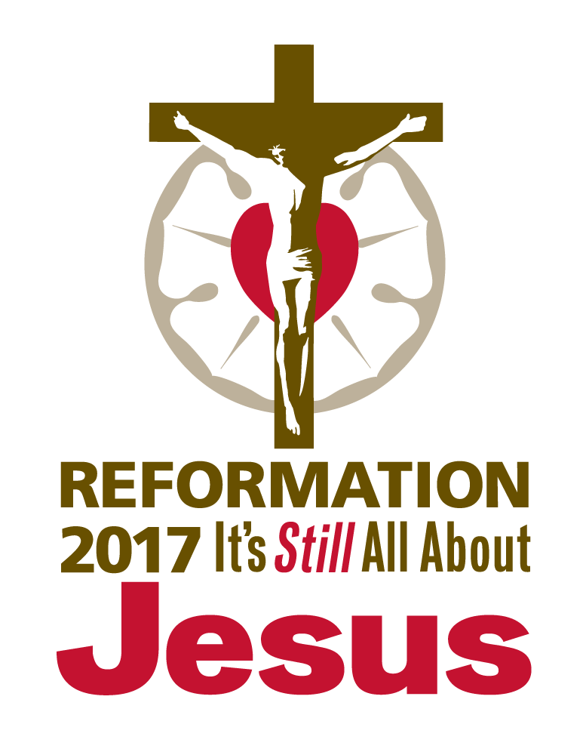
( ) Indicates instructions to the congregation, to appear in the worship folder

COMMEMORATION
OF MARTIN LUTHER

February 18, 2017
Observed: February 19, 2017

AS WE GATHER

The world revolves around birthdays. The Church calendar remembers the saints on their death days. Martin Luther was born on November 10, 1483, and died on February 18, 1546. Some might wonder why we commemorate him or any of the saints on the death day. This is why: Luther is not dead. Those who die in the Lord live with Him. To remember the day of death is to acknowledge that God comes to us in the midst of our sin and its death. He died in our place the fearful death so that we might live the life that has no end. His resurrection is the preview of our own joyful resurrection, with all the saints, to eternal life. Only in this hope can we know peace in the hour of our death and pray with the same confidence Luther prayed: “Into Your hand I commit my spirit; You have redeemed me, O Lord, faithful God” (Psalm 31:5). Our comfort in life and in death is not a feeling or a wish but the completion of that which God began in our Baptism, spoke to us in His Word, and nourished within us with the flesh and blood of Jesus, His Son.

CONFESSION AND ABSOLUTION

HYMN OF INVOCATION “Open Now Thy Gates of Beauty” [LSB 901; LW 198; TLH 1]

INVOCATION

The sign of the cross may be made by all in remembrance of their Baptism.

Pastor: In the name of the Father and of the Son and of the Holy Spirit.
People: Amen.

CONFESSION AND ABSOLUTION

Pastor: If we say we have no sin, we deceive ourselves, and the truth is not in us.
People: But if we confess our sins, God, who is faithful and just, will forgive our sins and cleanse us from all unrighteousness.

Silence for reflection on God’s Word and for self-examination.

Pastor: Let us then confess our sins to God our Father.
People: Most merciful God, we confess that we are by nature sinful and unclean. We have sinned against You in thought, word, and deed, by what we have done and by what we have left undone. We have not loved You with our whole heart; we have not loved our neighbors as ourselves. We justly deserve Your present and eternal punishment. For the sake of Your Son, Jesus Christ, have mercy on us. Forgive us, renew us, and lead us, so that we may delight in Your will and walk in Your ways to the glory of Your holy name. Amen.

Pastor: Almighty God in His mercy has given His Son to die for you and for His sake forgives you all your sins. As a called and ordained servant of Christ, and by His authority, I therefore forgive you all your sins in the name of the Father and of the Son and of the Holy Spirit.
People: Amen.

[OR] Based on Psalm 25:6–7; Philippians 1:6

Pastor: Remember Your mercy, O Lord, and Your steadfast love.
People: Remember not the sins of my youth or my transgressions;
Pastor: according to Your steadfast love remember me, O Lord.
People: For Your name’s sake, O Lord, pardon my guilt, for it is great.

Silence for reflection on God’s Word and for self-examination.

Pastor: Let us confess our sin in the presence of God and of one another.
People: I confess to God Almighty, before the whole company of heaven and to you, my brothers and sisters, that I have sinned in thought, word, and deed by my fault, by my own fault, by my own most grievous fault; wherefore I pray God Almighty to have mercy on me, forgive me all my sins, and bring me to everlasting life. Amen.

Pastor: The almighty and merciful Lord grant you pardon, forgiveness, and remission of all your sins. As a called and ordained servant of Christ, and by His authority, I therefore forgive you all your sins in the name of the Father and of the Son and of the Holy Spirit.
People: Amen.

Pastor: He who began a good work in you will bring it to completion in the day of Jesus Christ. The peace of the Lord be with you.
People: And also with you.

SERVICE OF THE WORD

INTROIT Psalm 119:46; Psalm 46:1–3, 7a

I will also speak of Your testimonies be- | fore kings*
and shall not be | put to shame.
God is our ref- | uge and strength,*
a very present help in | trouble.
Therefore we will not fear though the | earth gives way,*
though the mountains be moved into the heart | of the sea,
though its waters | roar and foam,*
though the mountains tremble at its | swelling.
Glory be to the Father and | to the Son*
and to the Holy | Spirit;
as it was in the be- | ginning,*
is now, and will be forever. | Amen.
The Lord of hosts is | with us;*
the God of Jacob is our | fortress.
I will also speak of Your testimonies be- | fore kings*
and shall not be | put to shame.

KYRIE (p. ___ in hymnal)

HYMN OF PRAISE (p. ___ in hymnal)

SALUTATION

Pastor: The Lord be with you.
People: And also with you.

COLLECT OF THE DAY

Pastor: Let us pray.
O God, our refuge and our strength, You raised up Your servant Martin Luther to reform and renew Your Church in the light of Your living Word, Jesus Christ, our Lord. Defend and purify the Church in our own day, and grant that we may boldly proclaim Christ’s faithfulness unto death and His vindicating resurrection, which You made known to Your servant Martin through Jesus Christ, our Savior, who lives and reigns with you and the Holy Spirit, one God, now and forever.
People: Amen.

[OR]

Pastor: Let us pray.
O Lord, You sent Your only Son to take upon Himself the heavy burden of our sin and to die in our place the fearful death of sin. Give us Your Holy Spirit that we may know with confidence Your mercy and rejoice that we belong to You in life and in death. Guide us by the strong voice of Your Word, which accomplishes Your purpose, and keep us in Your baptismal promise by faith, that abiding in Christ here on earth we may be kept to eternal life; through Jesus Christ, Your Son, our Lord, who lives and reigns with You and the Holy Spirit, now and forever.
People: Amen.

OLD TESTAMENT READING Isaiah 55:6–11 (Sowers of the seed propel the Word abroad.)

Lector: This is the Word of the Lord.
People: Thanks be to God.

PSALM Psalm 25:1–14 (15–22) [See service downloads for festival setting.]

EPISTLE Romans 10:5–17 (Teachers of the Word spoke the truth and
caused the Gospel to be heard.)

Lector: This is the Word of the Lord.
People: Thanks be to God.

ALLELUIA and VERSE Psalm 84:12 [See service downloads for festival setting.]

Alleluia. O Lord of hosts, blessed is the one who trusts in You! Alleluia.

HOLY GOSPEL John 15:1–11 (Engrafted to the living Vine)

Pastor: The Holy Gospel according to St. John, the fifteenth chapter.
People: Glory to You, O Lord.

(The Gospel is read.)

Pastor: This is the Gospel of the Lord.
People: Praise to You, O Christ.

CHILDREN’S MESSAGE [See service downloads for message resources.]

HYMN OF THE DAY “Christ, the Word of God Incarnate” [LSB 540; see service
downloads for festival settings.]

SERMON “Into Your Hand I Commit My Spirit” [See service downloads for sermon resources.]

CREED Nicene Creed (as found in the hymnal)

[OR]

All: I believe in one God,
the Father Almighty,
maker of heaven and earth
and of all things visible and invisible.

And in one Lord Jesus Christ,
the only-begotten Son of God,
begotten of His Father before all worlds,
God of God, Light of Light,
very God of very God,
begotten, not made,
being of one substance with the Father,
by whom all things were made;
who for us men and for our salvation came down from heaven
and was incarnate by the Holy Spirit of the virgin Mary
and was made man;
and was crucified also for us under Pontius Pilate.
He suffered and was buried.
And the third day He rose again according to the Scriptures
and ascended into heaven
and sits at the right hand of the Father.
And He will come again with glory to judge both the living and the dead,
whose kingdom will have no end.

And I believe in the Holy Spirit,
the Lord and giver of life,
who proceeds from the Father and the Son,
who with the Father and the Son together is worshiped and glorified,
who spoke by the prophets.
And I believe in one holy Christian and apostolic Church,
I acknowledge one Baptism for the remission of sins,
and I look for the resurrection of the dead
and the life of the world to come. Amen.

PRAYER OF THE CHURCH

Pastor: Having heard the Word of the Lord, let us pray with confidence in the name of Christ, for ourselves, for all the people of God, and for all people according to their needs.
Lord of all life, we pray for Your Church and all who come to know You through her work and witness. Keep us all from the assaults of the devil, from the weakness of our own mortal flesh, and from the temptation of the world, that we may serve You in holiness and righteousness all our days. Into Your hands, O Lord,
People: we commit ourselves, for You have redeemed us, O Lord, faithful God.

Pastor: Lord of love, we pray in thanksgiving for Martin Luther and for all those whom You have raised up to recall Your Church to the truth of Your Word. Bless all pastors, missionaries, church workers, and those preparing for church work, and prosper Your kingdom through their faithfulness. Into Your hands, O Lord,
People: we commit ourselves, for You have redeemed us, O Lord, faithful God.

Pastor: Lord of power, all the nations of the world are accountable to You. Give to Your people everywhere, but especially in this land, the blessing of good leaders who love justice, who act mercifully, and who uphold the sanctity of life from beginning to end. Grant peace to the nations, protection to those who defend us in the armed forces, and blessing to all police, firefighters, and emergency medical personnel. Into Your hands, O Lord,
People: we commit ourselves, for You have redeemed us, O Lord, faithful God.

Pastor: Lord of hope, Your people turn to You in their hour of need. Give to all victims of disaster the comfort of Your presence and the preservation of Your grace in all circumstances of need. Bless those who work on our behalf here and throughout the world to show forth Your mercy and care for the needy. Into Your hands, O Lord,
People: we commit ourselves, for You have redeemed us, O Lord, faithful God.

Pastor: Lord of mercy, send Your kindness upon all who suffer, upon the sick and those recovering, and upon the grieving and the dying. According to Your gracious will, sustain them in their afflictions, and grant them patience until they are delivered from the weakness of this mortal life, [especially . . .], and those whom we name before You in our hearts. [Pause for silent prayer.] Visit them with Your grace sufficient for all their needs. Into Your hands, O Lord,
People: we commit ourselves, for You have redeemed us, O Lord, faithful God.

Pastor: Lord of life, in whom all live who have died in Christ and now rest from their labors, grant to us who know You by faith and not yet by sight the presence of Your Spirit, that we may serve You faithfully without fear and rest securely in Your arms when this life is over. Receive our thanks for blessed Luther and all the faithful who have gone before us and now await with us the completion of all You began. Into Your hands, O Lord,
People: we commit ourselves, for You have redeemed us, O Lord, faithful God.

Pastor: These and all things that You know we need, grant to us according to Your fatherly wisdom and mercy. Into Your hands, O Lord, we commend ourselves and all for whom we pray, trusting in Your mercy through Your Son, Jesus Christ, our Lord.
People: Amen.

OFFERING

OFFERTORY (p. ___ in hymnal)

SERVICE OF THE SACRAMENT

PREFACE

Pastor: The Lord be with you. 2 Timothy 4:22
People: And also with you.

Pastor: Lift up your hearts. [Colossians 3:1]
People: We lift them to the Lord.

Pastor: Let us give thanks to the Lord our God. [Psalm 136]
People: It is right to give Him thanks and praise.

PROPER PREFACE

Pastor: It is truly good, right, and salutary that we should at all times and in all places give thanks to You, holy Lord, almighty Father, everlasting God, through Jesus Christ, our Lord, who on this day overcame death and the grave and by His glorious resurrection opened to us the way of everlasting life. Therefore with angels and archangels and with all the company of heaven we laud and magnify Your glorious name, evermore praising You and saying:

[OR]

Pastor: It is truly good, right, our duty, and our delight, at all times and in all places to give thanks to You, O Lord, through Jesus Christ, the Word made flesh, in whom You have revealed Your glory, rescued Your people from their sins, and redeemed to everlasting life all who believe in Him. Remembering those who renewed Your Church by the faithful preaching of the Gospel, we beg You to bring us with them into the blessed company of the saints in light immortal. Therefore, with angels and archangels, with patriarchs and prophets, apostles and evangelists, with Your servant Martin, and with all the company of heaven, we laud and magnify Your glorious name, evermore praising You and saying:

SANCTUS (p. ___ in hymnal)

PRAYER OF THANKSGIVING

Pastor: Blessed are You, Lord of heaven and earth, for You have had mercy on those whom You created and sent Your only-begotten Son into our flesh to bear our sin and be our Savior. With repentant joy we receive the salvation accomplished for us by the all-availing sacrifice of His body and His blood on the cross.
Gathered in the name and the remembrance of Jesus, we beg You, O Lord, to forgive, renew, and strengthen us with Your Word and Spirit. Grant us faithfully to eat His body and drink His blood as He bids us do in His own testament. Gather us together, we pray, from the ends of the earth to celebrate with all the faithful the marriage feast of the Lamb in His kingdom, which has no end. Graciously receive our prayers; deliver and preserve us. To You alone, O Father, be all glory, honor, and worship, with the Son and the Holy Spirit, one God, now and forever.
People: Amen.

[OR]

Pastor: Almighty God, our heavenly Father, we, Your unworthy servants, give You humble and hearty thanks for all the goodness and loving-kindness that You bestow on us. We praise You for our creation, preservation, and all the blessings of this life. Above all, we bless You for Your boundless love in the redemption of the world by our Lord and Savior Jesus Christ, for the Means of Grace, and for the hope of glory. Give us a right understanding of Your Word and appreciation for all Your mercies, that our hearts may be moved to gratitude and our lips and lives to praise Your goodness and serve You in lives of holiness and righteousness all our days.
O Lord, heavenly Father, we here remember the sufferings and death of Your dear Son, Jesus Christ, for our salvation. Praising His victorious resurrection from the dead, we draw strength from His ascension before You, where He ever stands as our High Priest. Gather us together, we pray, from the ends of the earth to celebrate with all the faithful the marriage feast of the Lamb in His kingdom, which has no end. Graciously receive our prayers, deliver and preserve us, for to You alone we give all glory, honor, and worship, Father, Son, and Holy Spirit, one God, now and forever.
People: Amen.

THE WORDS OF OUR LORD Matthew 26:26–28; Mark 14:22–24; Luke 22:19–20; 1 Corinthians 11:23–25

Pastor: Our Lord Jesus Christ, on the night when He was betrayed, took bread, and when He had given thanks, He broke it and gave it to the disciples and said: “Take, eat; this is My body, which is given for you. This do in remembrance of Me.”
In the same way also He took the cup after supper, and when He had given thanks, He gave it to them, saying: “Drink of it, all of you; this cup is the new testament in My blood, which is shed for you for the forgiveness of sins. This do, as often as you drink it, in remembrance of Me.”

PROCLAMATION OF CHRIST

Pastor: As often as we eat this bread and drink this cup, we proclaim the Lord’s death until He comes. 1 Corinthians 11:26
People: Amen. Come, Lord Jesus. Revelation 22:20

Pastor: O Lord Jesus Christ, only Son of the Father, in giving us Your body and blood to eat and to drink, You lead us to remember and confess Your holy cross and passion, Your blessed death, Your rest in the tomb, Your resurrection from the dead, Your ascension into heaven, and Your coming for the final judgment. So remember us in Your kingdom and teach us to pray:

LORD’S PRAYER (Matthew 6:9–13)

People: Our Father who art in heaven,
hallowed be Thy name,
Thy kingdom come,
Thy will be done on earth
as it is in heaven;
give us this day our daily bread;
and forgive us our trespasses
as we forgive those
who trespass against us;
and lead us not into temptation,
but deliver us from evil.
For Thine is the kingdom
and the power and the glory
forever and ever. Amen.

PAX DOMINI

Pastor: The peace of the Lord be with you always.
People: Amen.

AGNUS DEI (p. ___ in hymnal)

DISTRIBUTION HYMNS

“O Morning Star, How Fair and Bright” [LSB 395; LW 73; TLH 343]
“The Gifts Christ Freely Gives” [LSB 602]
“Evening and Morning” [LSB 726; LW 419]

POST-COMMUNION CANTICLE (p. ___ in hymnal)

POST-COMMUNION COLLECT

Pastor: We give thanks to You, almighty God, that You have refreshed us through this salutary gift, and we implore You that of Your mercy You would strengthen us through the same in faith toward You and in fervent love toward one another; through Jesus Christ, Your Son, our Lord, who lives and reigns with You and the Holy Spirit, one God, now and forever.
People: Amen.

[OR] Based on John 15:5

Pastor: “I am the vine; you are the branches,” says the Lord.
People: Abide in Me, and I will abide in You.
Pastor: Abide in Me, and you will bear much fruit;
People: Apart from Me you can do nothing.

Pastor: Loving God, we give You thanks for giving to us Your Word, our Lord Jesus Christ, whose obedient life and life-giving death have won salvation for us. We rejoice in the Holy Communion of His body and blood and pray You to keep what You have begun in us that, trusting in Christ our Savior, we may listen to the living voice of His Word, live out the new life given to us in our Baptism, and be brought with blessed Martin and all the saints to everlasting life; through Jesus Christ, our Lord.
People: Amen.

BENEDICTION

Pastor: The Lord bless you and keep you.
The Lord make His face shine on you and be gracious to you.
The Lord look upon you with favor and give you peace. Numbers 6:24–26
People: Amen.

HYMN “To You, O Christ, Be Thanks and Praise” [See service downloads for music.]

To You, O Christ, be thanks and praise
For saints and teachers of the Word
Who spoke Your truth in former days
And caused the Gospel to be heard.

We bless You, Lord, for those who searched
The Scriptures to discern Your grace
And by that pow’r renewed the Church
To shine Your light in ev’ry place.

Renew us still; our hearts incline
To hear Your Word and so remain
Engrafted to the living Vine,
Where we abundant life obtain.

Then give us courage to confess,
Like saints of old, Your holy name
And trust that You will ever bless,
Nor let Your own be put to shame.

May we, like sowers of the seed,
Propel the Word of life abroad
To reach a hungry world in need
With good news of a gracious God.

[OR]

“May God Bestow on Us His Grace” [LSB 823/824; LW 288; TLH 500]
ACKNOWLEDGMENTS
Published by Concordia Publishing House
3558 S. Jefferson Ave., St. Louis, MO 63118-3968
1-800-325-3040 • www.cph.org
Copyright © 2016 The Lutheran Church—Missouri Synod
Other than downloading this resource for personal, Bible study, classroom, or congregational use, other usage is prohibited. No part of this material may be transmitted in any form or by any means, electronic, mechanical, recording, or otherwise, without prior written permission of Concordia Publishing House.
Scripture quotations are from the ESV® Bible (The Holy Bible, English Standard Version®), copyright © 2001 by Crossway, a publishing ministry of Good News Publishers. Used by permission. All rights reserved.
“To You, O Christ, Be Thanks and Praise” copyright © 2016 Concordia Publishing House.
Some liturgical material taken from Lutheran Service Book, Divine Service: Setting One, copyright © 2006 Concordia Publishing House. Used by permission. All rights reserved.
Service author Larry Peters
“To You, O Christ, Be Thanks and Praise” (text) David W. Rogner
“To You, O Christ, Be Thanks and Praise” (music) Amanda Husberg
Psalm, Verse, and Hymn of the Day settings Jonathan Kohrs

